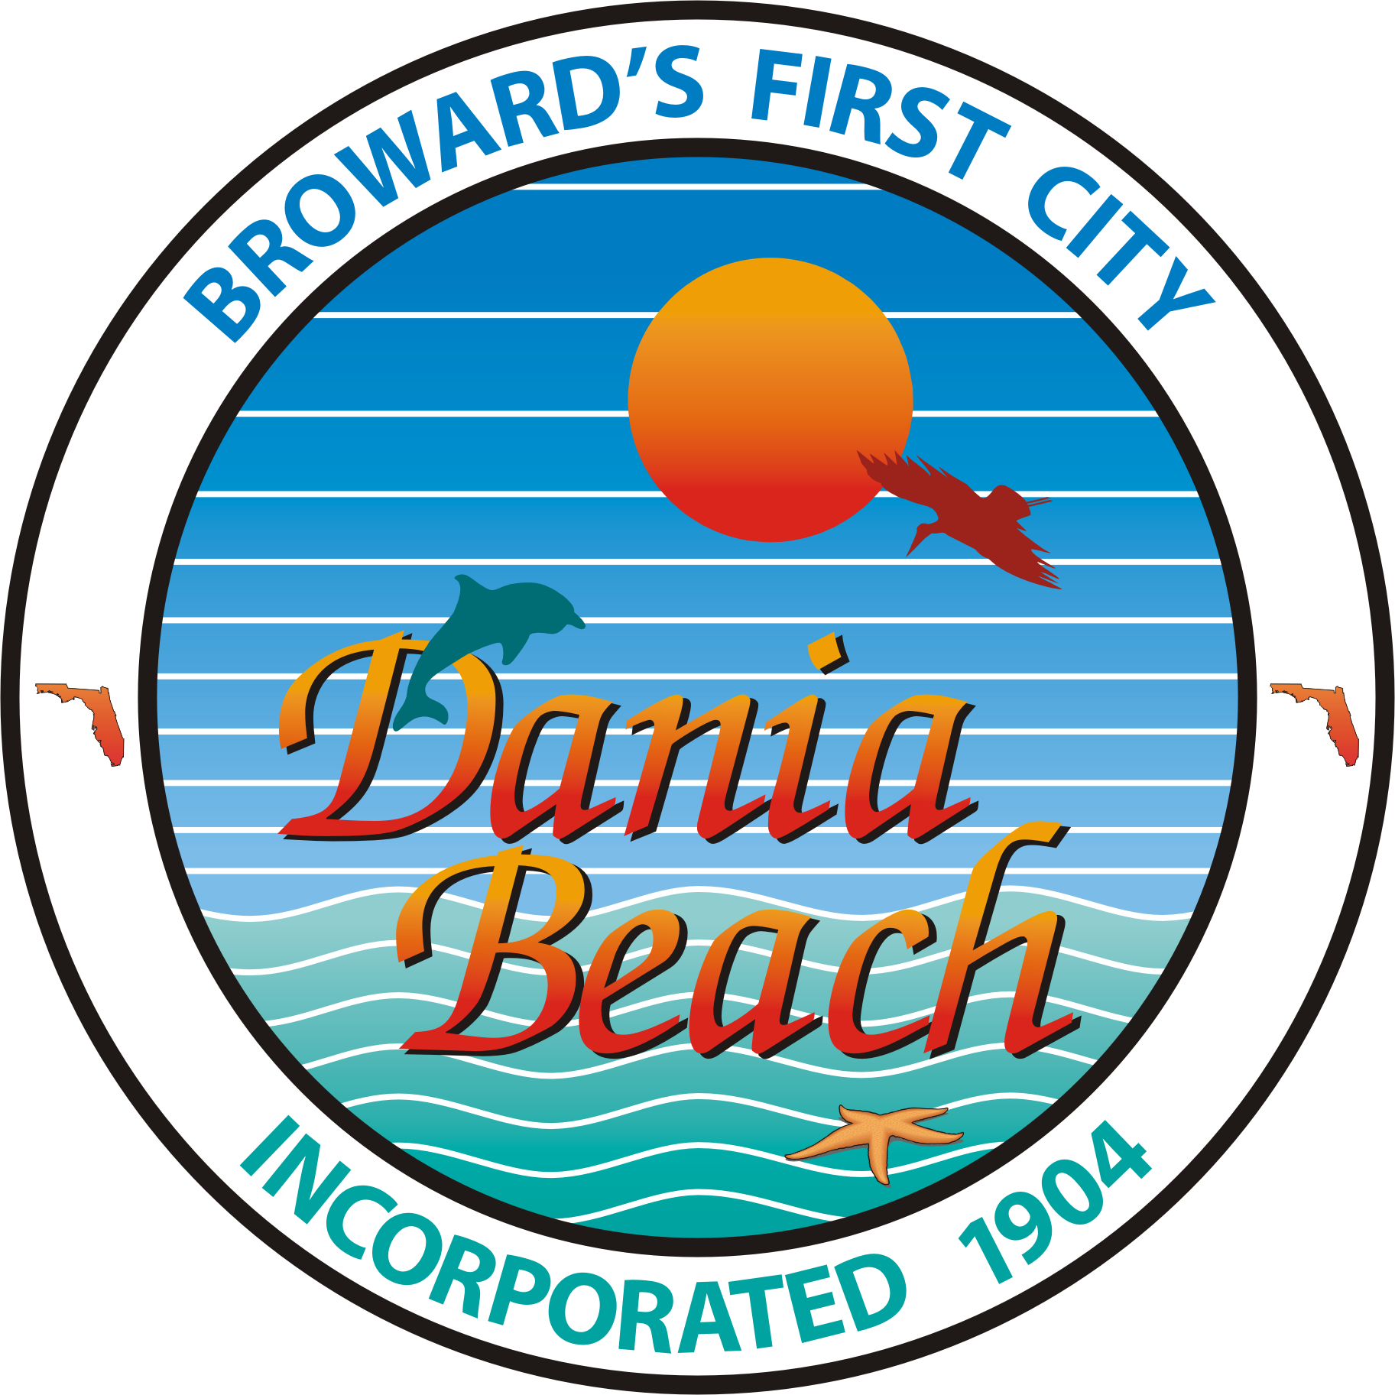
CITY OF DANIA BEACH
MEMORANDUM

TO: Honorable Mayor and Commissioners

FROM: Robert Baldwin, City Manager

By: Mark Bates, Finance Director

DATE: July 24, 2012

SUBJECT: 3-Party Lease Agreement – City Fire Truck Loans

The City of Dania Beach financed the purchase of its new Fire Ladder Trucks with T.D. Equipment. Under the terms of this lease, the City retains ownership of the equipment as a security for the loans.

With the transfer of City fire services to the BSO in January 2011, the City found it necessary to develop a separate 3-party lease agreement for this equipment loan that was acceptable to T.D. Equipment, BSO-fire and our City. This new lease allows BSO-fire to continue use and maintenance of the City’s 2 ladder trucks without altering the ownership and loan security of the City during the 10-year term of the loan.

During the course of the past year, our City Attorney has negotiated and completed development of an acceptable 3-party lease that all entities have approved. The attached Resolution approves the City’s acceptance and authorizes appropriate City individuals to execute this 3-part lease on behalf of the City of Dania Beach.

The Administration recommends Commission approval.

